NAME: GRADE: SUBJECT:
SUBMISSION DATE: PARENT SIGNATURE:

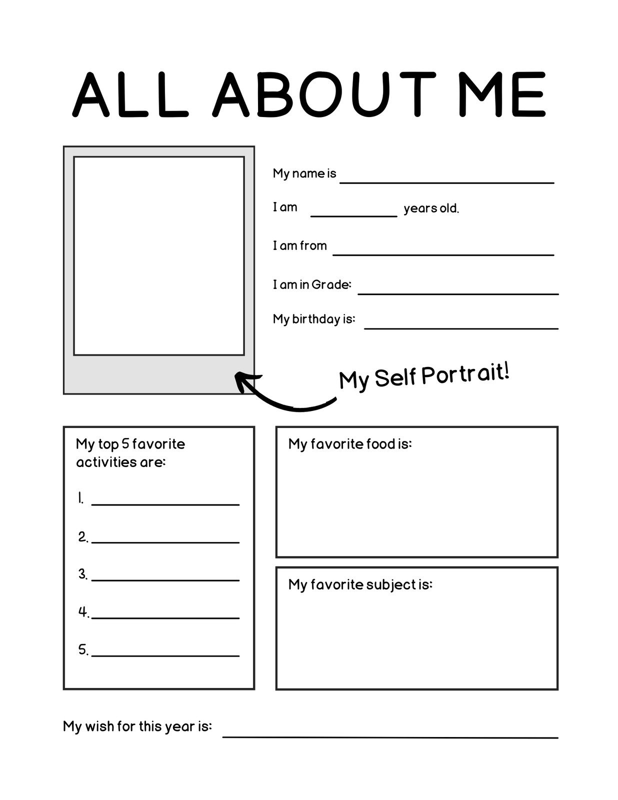
Fill in the blanks with the picture clue given below

- I see with my ______________.
- I hear with my _____________.
- I smell with my _____________.
- I taste with my _____________.
- I touch and feel with my _____________.

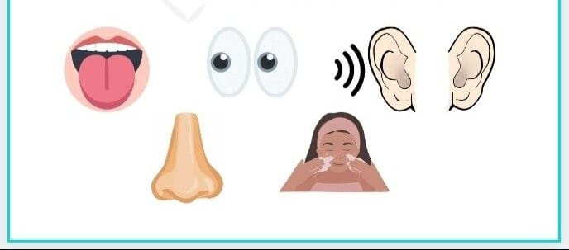

Name and match the body parts involved in body movements
